# SQL Server Assignment

1. By using a relational database **of your choice** load the csv file in a table called **india_telecom_data_speeds**.

Describe the steps taken to load this data inside your database and attach an image of the table created.

create database TRAI

use TRAI

and then loading the data from .csv file to SQL server

Steps:

-->Open MSSQL SQL Server Management Studio, bydefault Servername will be selected, then Select Windows Authentication and then click on Connect.

-->Select Object Explorer then Expand the Databases Folder.

-->Select the TRAI Database, Right-click on database and then select Tasks and then click Import Data.

-->Click the drop-down list and select Flat File Source,then click Next.

-->Click on Browse and specify the path of the CSV file and then click on Open.

-->Click on Next

-->Select Microsoft OLE DB Provider for SQL Server,then select the Server name and select Windows Authentication and then Select the Database name and click Next.

-->Bydefault Database and Table are selected and then click on Edit Mappings, Create destination table should be selected and then Click on OK.

-->In the next Window Run Immediately checkbox should be selected and then click on Next.

-->Click on Close.

Data loaded successfully into SQL Server.select * from india_telecom_data_speed

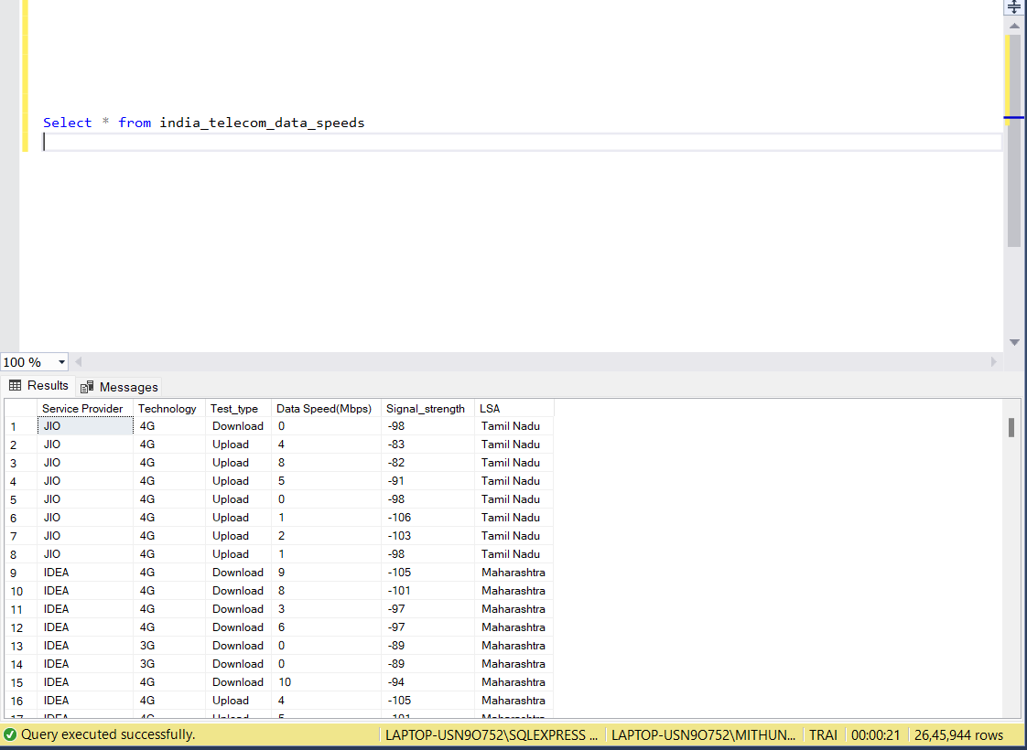

2. Out of the 1.3 million sample data set, how many had Technology **3G** vs **4G**?

select Technology, count(*) as '3G vs 4G' from india_telecom_data_speeds group by Technology

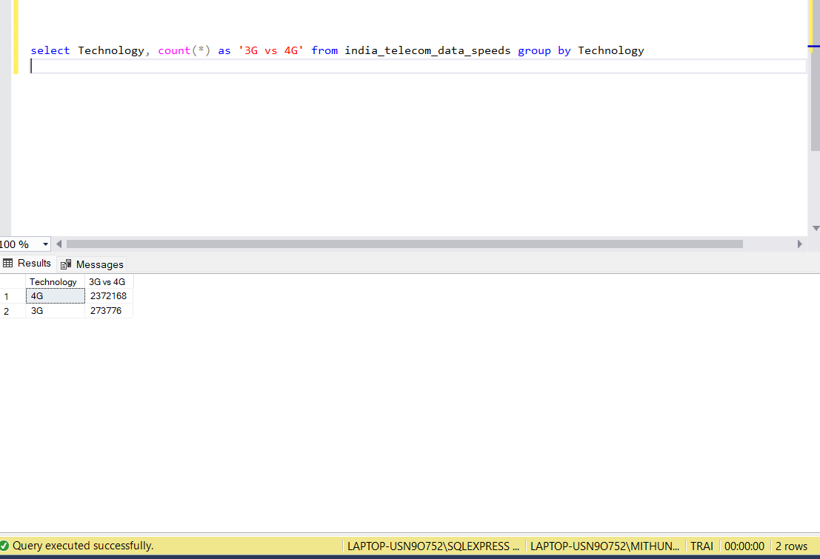

3. Calculate the **mean** download speed for **each** Service Provider.

select [service provider], AVG ([Data Speed(Mbps)]) as 'Mean' from india_telecom_data_speeds where [Test_type]='Download' group by [service provider]

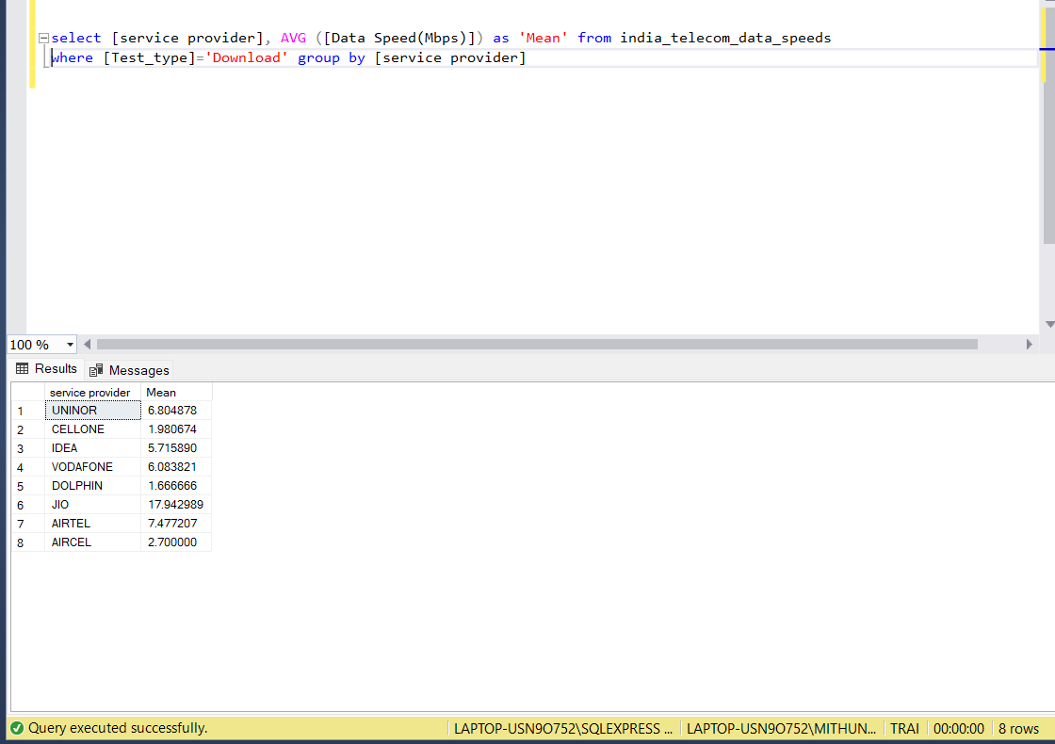

4. Which Service Provider provides the best mean download speed? Is there any correlation between speed and technology? Why?

select top(1) [service provider], AVG ([Data Speed(Mbps)]) as 'Mean' from india_telecom_data_speeds where [Test_type]='Download' group by [service provider] order by Mean desc

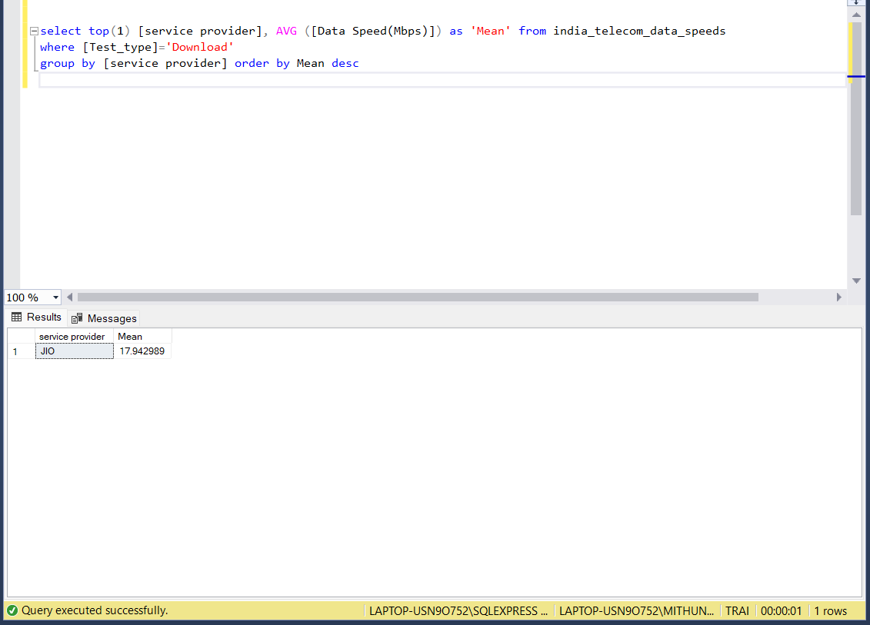

5. Calculate the **mean** upload speed for **each** Service Provider. Which Service Provider provides the best mean upload speed?

select top(1) [service provider], AVG ([Data Speed(Mbps)]) as 'Mean' from india_telecom_data_speeds where [Test_type]='upload' group by [service provider] order by Mean desc

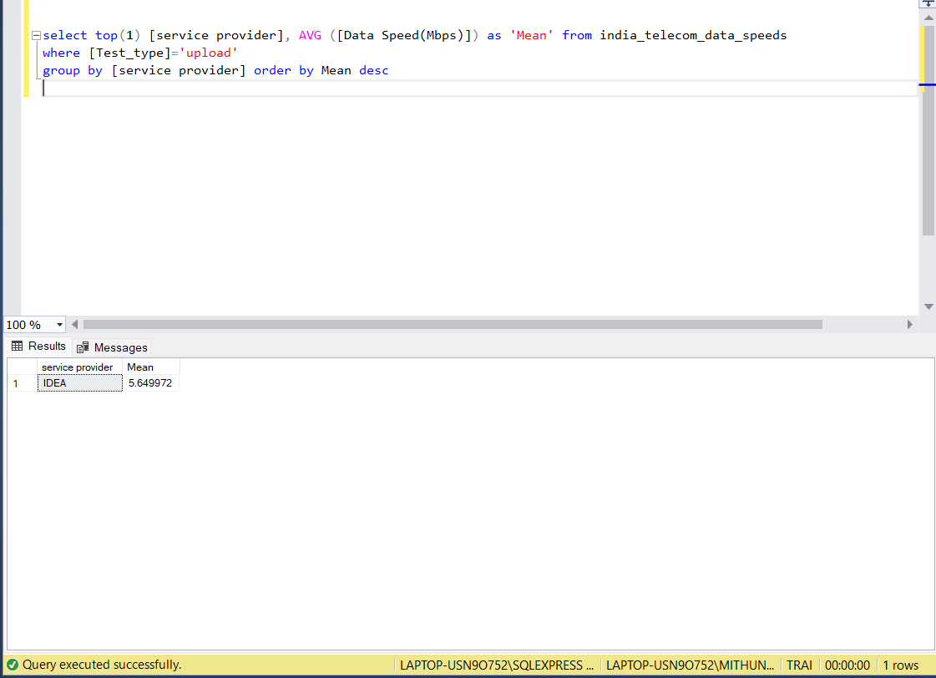

6. For **each** LSA , print out the Service Provider that had to **worse** Signal_Strength

(the worse signal strength is the value which is the greatest in the negative). Output should have 23 rows (one for each LSA) and 3 columns.

select [LSA] as 'LSA',max([Service Provider]) as 'Service Provider', min([Signal_strength])as 'Signal strength' from india_telecom_data_speeds group by [LSA]

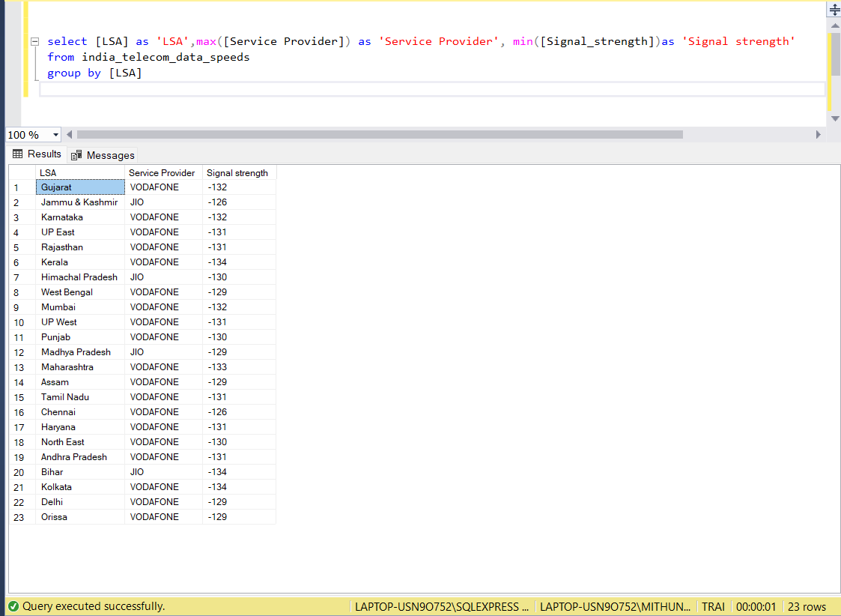

7. Using your newly created table india_telecom_data_speeds, create a Stored Procedure with two parameters which are used within the underlying

query as a filter for Service_Provider and Technology fields. The output of the stored procedure should include all the fields.

CREATE PROCEDURE [dbo].[usp_india_telecom_data_speeds]

@Service_Provider nvarchar(30),@Technology nvarchar(30)=null

AS

BEGIN

SELECT * from india_telecom_data_speeds where [Service Provider]=@Service_Provider and Technology=@Technology

END

Exec [usp_india_telecom_data_speeds] 'Airtel', NULL

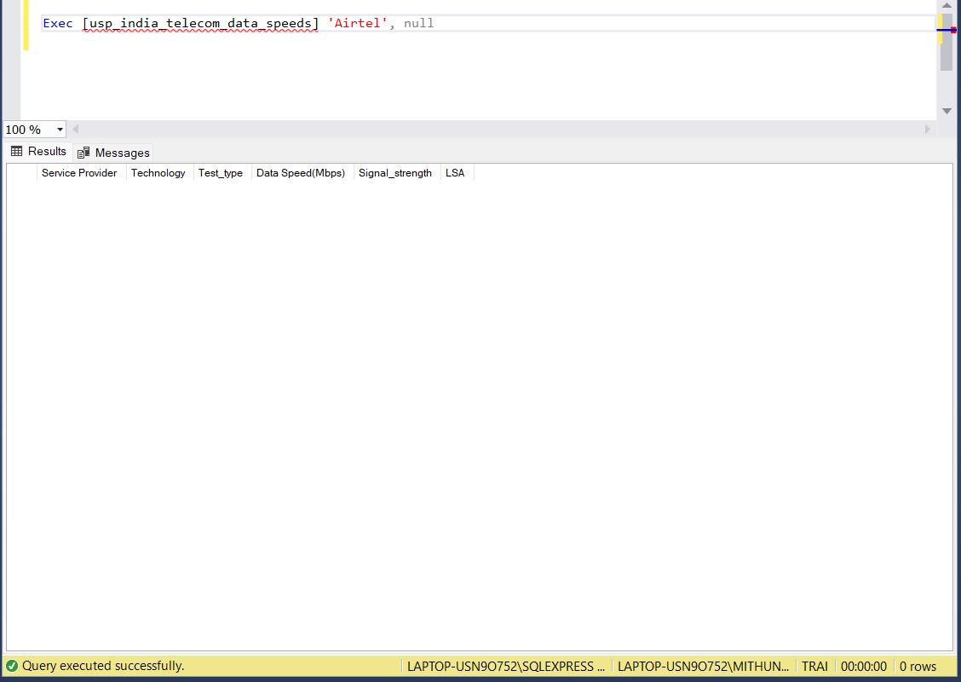

Exec[usp_india_telecom_data_speeds]'Airtel','4G'

